INSAR 2021 Submission (Max 500 words; Max 2 graphics)

Title: Predictors of Treatment Response using the Brief Observation of Social Communication Change (BOSCC).

Authors: Rebecca Grzadzinski, Kevin Donovan, Kinh Truong, Alison Holbrook, Catherine Lord, Sophy Kim

Background: The Brief Observation of Social Communication Change (BOSCC) is a coding scheme of ASD symptoms that is used as a treatment response measure. The BOSCC coding scheme has been validated in a study of toddlers who participated in early interventions (n=56) over the course of about 6 months (Grzadzinski et al., 2016). In this work, the coding scheme was applied to 10-minute videos of parent-child free-play sessions (Standard BOSCC). Subsequent work aimed to validate the coding scheme when applied to segments of ADOS administration videos (ADOS-BOSCC; Kim, Martinez, Grzadzinski, & Lord, 2019). These works confirmed the utility of the BOSCC as a treatment outcome measure when applied to parent-child and clinician-child interactions. Though these projects used an overlapping sample of children participating in early intervention trials, whether the children who show improvements on the Standard BOSCC are the same as those that show change on the ADOS-BOSCC is unknown. Further, the impact of baseline child characteristics on amount of improvement on the Standard BOSCC vs. ADOS-BOSCC is explored.

Objectives: 1. To provide a data-driven definition of “improvers”, 2. To evaluate the overlap between ADOS-BOSCC and Standard BOSCC groups, and 3. To determine whether there are characteristics that predict group status.

Methods: The Standard-BOSCC and ADOS-BOSCC was gathered on the same day for toddlers participating in an intervention trial (n=49; X males; age=29 + 10) over the course of ~9 months (+5). Two domains of the Standard-BOSCC and ADOS-BOSCC were assessed separately: Social Communication (SC) and Restricted, Repetitive Behaviors (RRBs). Children were administered the Mullen Scales of Early Learning (MSEL) to assess verbal and non-verbal developmental level (DL). An alpha value of 0.01 was used to account for multiple comparisons.

Results: Latent Growth Trajectory analyses revealed good model fit (INSERT DETAILS; see Figure 1) for a three-class result in SC domain: Mild Improvers (n=8,13), Moderate Improvers (n=22,21) Significant Improvers (n=19,15), as well as a three-class result in the RRB domain Improvers (n=14,23), Stable (n=25,19), Worseners (n=10,7) across both Standard-BOSCC and ADOS-BOSCC, respectively. There was observed consistency across ADOS-BOSCC and Standard-BOSCC class membership. Child baseline skills (intercept) for Standard-BOSCC SC and ADOS-BOSCC RRB as well as baseline symptom severity (ADOS-CSS-SA) for Standard BOSCC SC were significant predictors of group membership. Verbal and Non-Verbal DL at baseline were significant predictors of group membership for Standard-BOSCC and ADOS-BOSCC SC. See Figure 2.

Conclusions: Standard-BOSCC and ADOS-BOSCC are relatively consistent in determining who is improving over the course of an intervention. Verbal and Non-Verbal skills predict how much a child will improve over a relatively short intervention such that higher Verbal and Non-verbal skills predict more improvement in SC across both Standard and ADOS-BOSCC. In contrast, symptom severity and baseline BOSCC had differing impacts on amount of improvement in standard vs. ADOS-BOSCC. These results highlight that early intervention researchers should consider child verbal and non-verbal developmental level when assessing what a “meaningful” amount of improvement is over short periods of time.

Figure 1: Cluster fit indices for each BOSCC/ADOS BOSCC measure, for various number of clusters, using Bayesian Information Criterion (BIC). Lower BIC implies better fit.
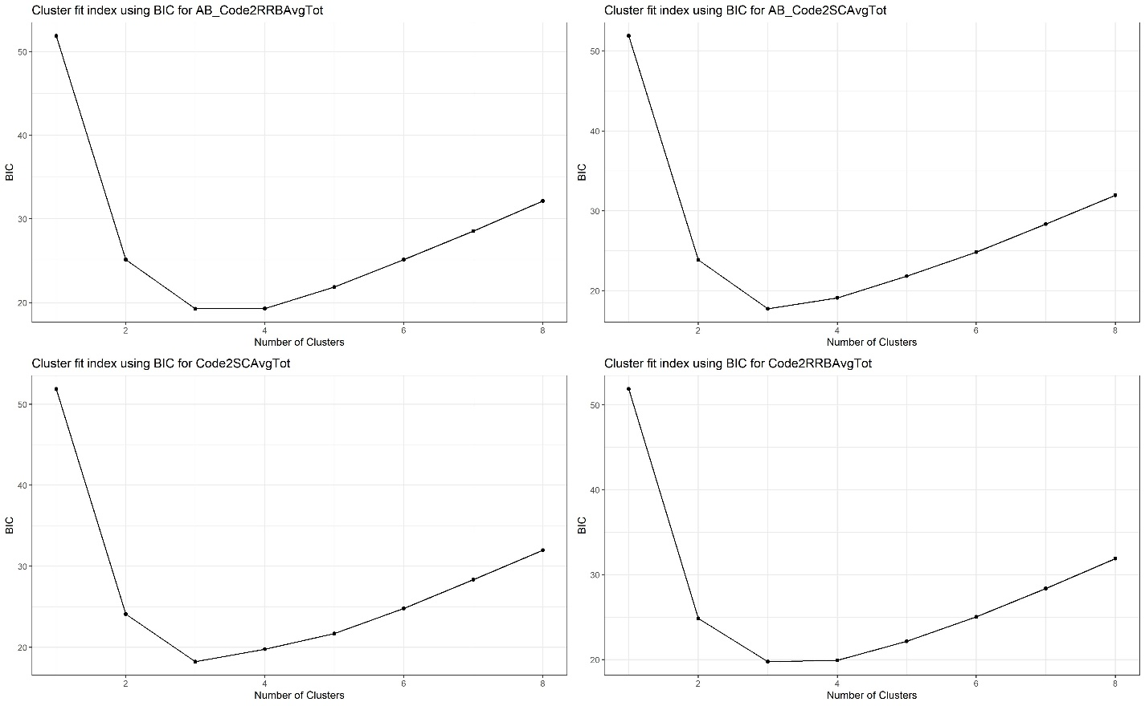

Table 1: Counts of cluster membership for RRB and SC scores, with percentage in parentheses. Columns denote standard BOSCC and rows denote ADOS BOSCC.
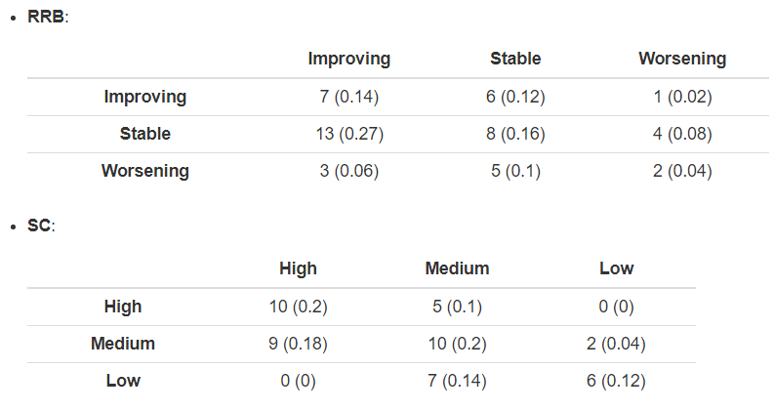

Figure 2:
